LOS PADRES COUNCIL (LPC) COVID – 19 GUIDANCE
Monday, September 20, 2021

To: All LPC Volunteers and Employees
In Scouting, we promise to do our best. As we are trying to move ahead, the Risk Management committee is reviewing federal, state, and county guidelines to assure we are functioning within them and trying to do our best to get the “outing” back in Scouting. We thank you for your commitment and patience on this most important of issues.

The safety of Scouts, volunteers, employees, and our communities are our top priority.

With safety and risk management in mind and based on guidance from health officials, the LPC has adopted the following procedures for council, district, and unit activities.

Anyone who feels any symptoms of becoming ill or any type of illness, should not attend any event, meeting, or outing

CAMPING / OVERNIGHT ACTIVITIES: are currently permitted – Please see the “Gatherings” information below

GATHERINGS: are currently permitted, as advised by health authorities. In general, the more people from different households a person interacts with at a gathering, the closer the physical interaction is, and the longer the interaction lasts, the higher the risk that a person with a COVID-19 infection, symptomatic or asymptomatic, may spread it to others. Public health studies have also shown that the risk of transmission is increased in indoor spaces, particularly in the absence of appropriate ventilation.
Unlike indoor spaces, wind and air in outdoor spaces can help reduce spread of the virus from one person to another. Increase fresh air circulation by opening windows or doors, as much as possible, especially in the rooms where people are gathering

Indoor and outdoor gatherings are currently permitted with the following guidelines:
- Approval should be obtained from the Chartered Organization and the meeting site owner/manager.
- In both Santa Barbara and San Luis Obispo Counties, for all Scouting Units, activities, and events (both youth and adult), masks MUST be worn by everyone when indoors, except when eating or drinking and with a few specific exceptions. Please see County web sites at the end of this Guidance for details.
- The CDC has advised that N – 95 masks offer a higher level of protection than cloth masks.
- Inform family members of all participants that participation is optional and that by participating they accept any responsibility due to COVID 19 exposure and will not hold LPC, BSA, volunteers, or Chartered Organization liable for exposure.
- SOCIAL DISTANCING – should maintain at least 6 feet between participants.
- HAND WASHING – washing with soap and water for 20 seconds is ideal. Hand sanitizer is an option when soap and water is not available.
- ILL OR EXPOSED – any individual who is ill or has been exposed to an active COVID 19 case should not participate until negative test has been confirmed.
- YOUTH PROTECTION – continue to follow all YPT guidelines (no one on one contact, 2 deep Leadership) and the Guide to Safe Scouting) at all times.

ADDITIONAL GUIDANCE FOR PLANNING AND CONDUCTING GROUP OUTINGS
- Avoid places that the public frequents, such as food service facilities and recreation sites with high use
- Ensure that pre-event medical / health screening is conducted for all participants – see the link below for guidance.
  - https://filestore.scouting.org/filestore/HealthSafety/pdf/680-057.pdf
  - https://www.scouting.org/health-and-safety/safety-moments/pre-event-medical-screening/
- Avoid sharing project and activity materials and equipment

FOOD SERVICE
- Everyone must practice hand washing before and after eating
- Masks may be lowered or removed while eating or drinking but must be put back on as soon as they are done with the eating or drinking.

HOW TO WEAR AND ROMOVE FACE COVERING
- Put the face covering on BEFORE you enter an area where it is required
- Ensure that it covers the mouth and nose
- Ensure that it fits firmly with no gaps at the nose, chin, and cheeks
- Do not touch the face covering while it is being worn

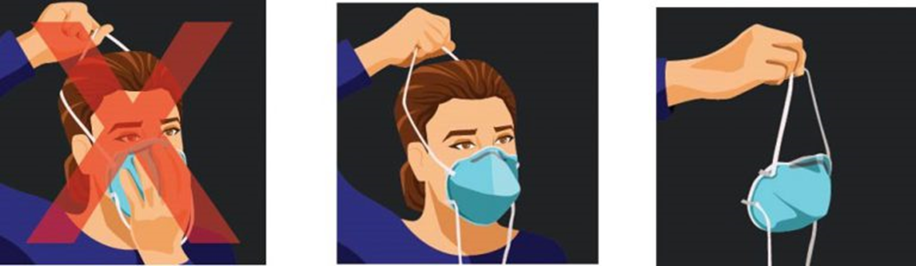

Acceptable face coverings:
- Disposable masks- replace when they become soiled and at the end of each day.
- Cloth face masks – launder in hot soapy water daily.

We will continue to evaluate the ongoing situation and prioritize the safety of everyone involved in Scouting. Youth, families, volunteers, employees, and our communities – are our number one priority.
We realize these decisions are not without their challenges, and we thank you for helping meet the needs of our communities in difficult times.
The steps we are taking reinforce the many ways – big and small – that Scouting empowers character and leadership today and for generations to come.

RESOURCES:
US CDC web site
https://CDC.gov
CA DPH web site
https://covid19.ca.gov/safer-economy/
SLO County web site
https://www.emergencyslo.org/en/covid19.aspx
Santa Barbara County web site
https://publichealthsbc.org/
https://publichealthsbc.org/purple-tier/

Carlos Cortez
Scout Executive / CEO
Carlos.cortez@scouting.org

George Brown
LPC Risk Management Committee Chair
805 459 4225
Kf6pbl@hotmail.com

NOTE – LPC employees must continue to abide by relevant CAL-OSHA guidance.

REV 1 w/ Track Changes - WED 20 SEP 2021

